Part 1

# Abstract:

The purpose of the investigation is to look at the pattern of the power usage with the power meter data. I have recorded some of the power meter record for this investigation. I have record 2 days of my power meter, with around 1-3hour in between every record. The purpose of these investigation is to identify the highest peak of the day and the time at which it occurs, as well as the baseline power usage.

# Background:

For this investigation I have chosen to use the data from my house. The simulation allows me to identify the power consumption in my house for two days. This data is chosen as it is easily accessible for me and I am able to record it with a small 1-3 hour gap in each record. This allows the data to be more accurate and the highest/lowest peak date and time will also be more accurate as I have more data.

# Methodology:

For this investigation I have put the data in to an single data file. The file contain the date and time and the power recorded. And then the data is pass through to the Part1.py program as an input. The data is then separated using pandas, and plotted using matplotlib. The cumulative graph is plotted by simply using the record from the data file. And the non-cumulative graph is plotted by using the .diff() function to get all the differences in between each record. And for the graph that shows record for each day, it is done by sorting the date and uses a for loop to plot multiple graph.

# Result:

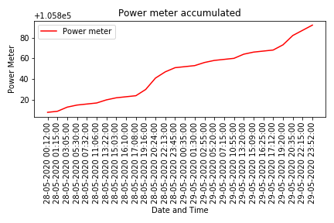

Figure - Cumulative graph

From the cumulative graph we can see that there is a high increase at 28/05/2020 19:16

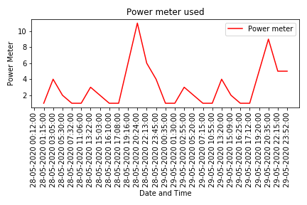

Figure - Non cumulative graph

For the non cumulative graph we can clearly sees the differences between each record, allowing me to identify that around 28/05/2020 19:16 my house has consume the most power. With an increase of more than 10 time the baseline usage. We can also identify the baseline usage to be around 1kWh.

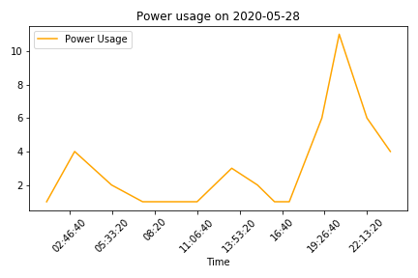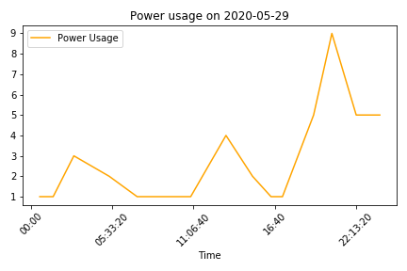

Figure - power usage on 28/5/2020 and 29/5/2020

This two graphs allow us to compare the difference between two days. We can see that the pattern of the data are really similar, which proves that the amount of power usage each day is around the same for multiple days. And the timeframe of the maximum usage is also around the same time each day.

# Conclusion and future work:

To concluded this investigation, I have identify the highest power usage which is around 28/05/2020 19:16, and it seems to be consistence during the two days of record. The power usage also seems to be consistence each days.

For further investigation, the solar panels might have an effect in my house which create those spike in the graph, I could try to record the solar panel and compare this investigation result with the solar panel record.

Part 2

# Abstract:

The purpose of the investigation is to look at the pattern of the power usage for each different devices in my house. For this investigation I have recorded the usage time as well as the power rating of each devices throughout my house. This investigation will gives me an idea on which devices is using the most power and which devices is used the most. It should also tell us the amount of power that’s used in each hour.

# Background:

For this investigation I have chosen to use the data from my house. The simulation allows me to identify the power consumption in my house for 24 hours. This data is chosen as it is easily accessible for me and I am able to record it accurately. This investigation also allows me to look at and compare the usage of each devices.

# Methodology:

For this investigation I have put the data in to an single data file. The file contain the residents number, each devices name, power rating, and the hour used. This file is then passes to the program Part2.py and separated in to an array. First I ran two for loop to separate all the data to their individual array which I am then able to use it to plot each graph. I have also sorted the device/power usage graph in an descending order, so that we can identify the highest consumption easily.

# Result:

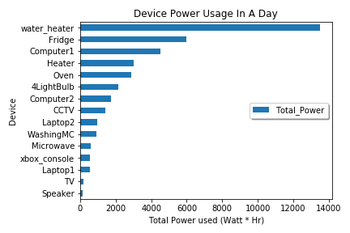

Figure - Device usage per day

This graph shows the amount of power that is used for each devices in a day. Here we can see that the water heater is using the most amount of power in my house. And the second highest power usage devices being the fridge. And computer being the third highest. However we can sees that even though the Fridge is second, it doesn’t even used half of the amount of water heater power usage.

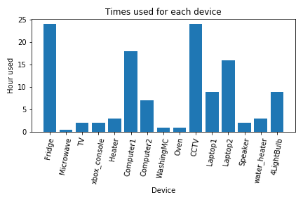

Figure - Time used for each device

This graph shows that the amount of time each device is being used in a day. Notice that fridge and CCTV is on for the whole day, yet when we look at the graph at figure 4, they don’t even used as much as the water heater. We can see that the water heater is only turned on for around 4 hours per day, yet it has used double the amount of power the fridge has used for the whole day. Comparing this figure 5 and figure 4, we can see that even though the hour usage might be long, it does not correspond to the total power usage as much.

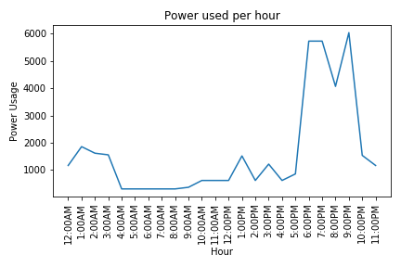

Figure - power used per hour

From this graph we can see the total power usage per hour. This combines the power usage of each device for each hours. We can see that at exactly 5PM we have used a huge amount of power, almost 6 times higher compare to 4PM. This is highly likely due to the usage of the water heater. And comparing this graph to the result from part A, we sees a similar pattern, where more energy is used at around afternoon and midnight. This further proof the result of part A and part B.

# Conclusion and future work:

To concluded this investigation, I have identify the device with the highest power usage which is water heater, fridge, and computer. And I have also found out that the highest amount of power usage happened during 5PM to 1AM. And I was able to compare this result to part A, which gives me a similar pattern of usage.

For further investigation, I think that the solar panels might influence the graph as it will lower the usage of the devices making it more accurately reflect the data and pattern from part A. For further improvement I can include more devices in my record and deduct the power provided by the solar panel.

Part 3

# Abstract:

The purpose of the investigation is to simulate a street and look at the power usage patten in the view of an electricity provider. For this investigation I have used the data for each house type on Piazza (referenced in the reference section). This investigation will gives me an estimate on how much energy will a street/suburb used. As well as the difference of each house type.

# Background:

For this investigation I have chosen to use the data from Piazza. The simulation allows me to identify the power consumption in every house type. This data is chosen as it is easily obtained and it is more realistic as it is from each student household, instead of making up data for the simulation. This investigation allows me to look at and compare the usage of each household as well as the total energy of the street/suburb.

# Methodology:

For this investigation I have 4 different household data from piazza and I have created a streetInfo.csv file as an input for my Part3.py program. I have also created Part3Class.py as an class to store all the separation and calculation so I can easily import and uses all the function for Part3.py

The code for part3Class.py is essentially the code in part2.py with some minor changes to an class.

In part3.py I imported part3Class.py and used it to read the file that is in streetInfo.csv and give me the usable data. I then use a few for loop to plot the graph that I need. I am able to plot the graph by using an array to store the data and a for loop to plot each data to the graph.

# Result:

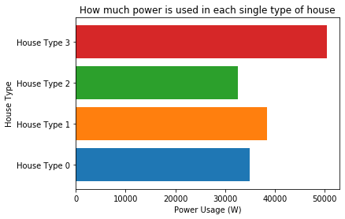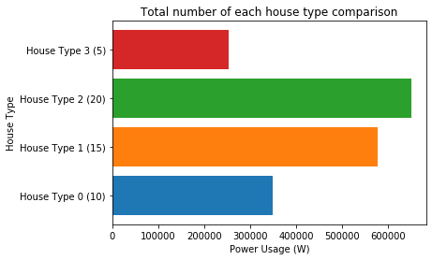

Figure - single house type (left) and multiple house type (right)

On the left we have the power usage of each house type. On the right we have the total power usage of the multiple house type in a street/suburb. (Eg. 5 house type 3 , 20 house type 2, 15 house type 1 , 10 house type 0)

This shows that due to a high amount of house type 2 in the suburb, even though the house type 2 have the lowest power usage, it still makes up the highest total amount. While house type 3 uses the most power individually , it only have 5 house in the suburb and therefore it didn’t have as much total power usage compare to the other.

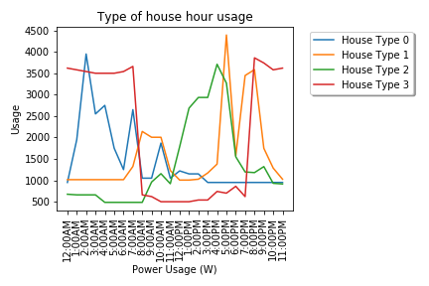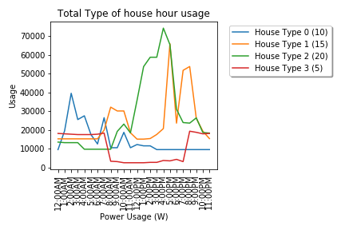

Figure - single house type hour usage (left) , multiple house type hour usage (right)

In this two graph it shows the power usage of each house type. For house type 3, it seems like a house that use the most energy during the night. While House type 2 seems like a normal household using most power in between 11AM and 7PM. As for house type 1, we sees that it seems to have a steady usage throughout the day with a bit of spike at 5PM. Lastly for house type 0, it seems to use the most power past mid night, around 12AM to 7AM. However looking at the right graph we can see that after all the highest amount of power usage is still around 12PM to 9PM, this is largely due to the huge amount of house type 2 and house type 1 in the suburb.

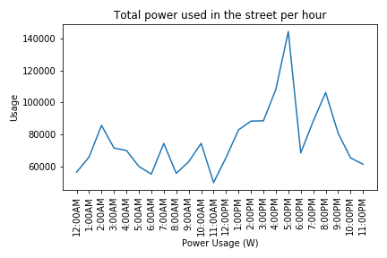

Figure - total power used in the suburb/street per hour

This proof our assumption that the highest amount of power usage is still around 12PM to 9PM. As this shows the total power usage of the street/suburb. We can see that even though some of the house type have an huge amount of power usage at night, the total power usage is still peak at the time of noon. And the reason why this happen can be seen in the pie chart below.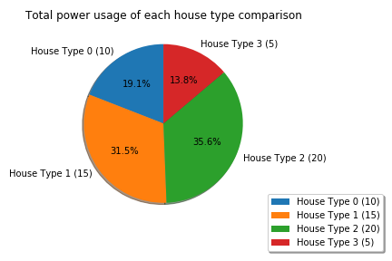

Figure - Total power usage pie chart

From this pie chart we can see that 35.6% of the total power usage is from Type 2 and 31.5% of the total power usage is from type 1. This hugely affect the graph on figure 9, as almost 67% of the total power is mainly affect by the house type 1 and 2. While the house type that have a majority power usage at night only add up to around 33%.

# Conclusion and future work:

To concluded this investigation, I have identify that each house type have an different pattern of power usage and that in this simulation majority of the power usage happens in between 12PM to 9PM, with the highest being 140000 watt. And the lowest being less than 30000 watt. We are able to see the percentage of each house type contribute to the total power usage.

For further investigation, I think that the solar panel might impact the graph. For further improvement I can add the solar panel to some type of house and see if it will create an different patterns.

# Reference:

Piazza. 2020. “Model Data for Assignment.” *COMP1005*(blog), May 31, 2020. Post 335_f1. <https://piazza.com/class/k74j7ie5eo75vt?cid=355>

Piazza. 2020. “Model Data for Assignment.” *COMP1005*(blog), May 31, 2020. Post 335_f7. <https://piazza.com/class/k74j7ie5eo75vt?cid=355>

Piazza. 2020. “Model Data for Assignment.” *COMP1005*(blog), May 31, 2020. Post 335_f6. <https://piazza.com/class/k74j7ie5eo75vt?cid=355>

Piazza. 2020. “Model Data for Assignment.” *COMP1005*(blog), May 31, 2020. Post 335_f4. <https://piazza.com/class/k74j7ie5eo75vt?cid=355>